## **SAP - APPROVAL WORKFLOW**

**Menu**

1. **Menu - Masters:**

* Company Master
  + Data Addition without Error. - Test Pass
  + Edit the record without Error. - Test Pass
  + Company code(Unique) **duplicate** should not allow - Test Pass
  + Company code Should **not be Edited**. - Test Pass
  + Company Name, Company Logo and Active Status are **Editable** - Test Pass
  + Active / In-active can be enable while edit. - Test Pass
  + Access to be **Admin User Only.** - Test Pass

* Business Decision Master
* Data Addition without Error. -Test Pass
* Edit the record without Error. - Test Pass
* Business Decision code(Unique) **duplicate** should not allow -Test Pass
* Company code and Business Decision code Should **not be Edited**. -Test Pass
* Business Decision Address and Active Status are **Editable** - Test Pass
* Active / In-active can be enable while edit.
* Access to be **Admin User Only**. - Test Pass
* Plant Master
* Data Addition without Error. -Test Pass
* Edit the record without Error. - Test Pass
* Plant code(Unique) **duplicate** should not allow -Test Pass
* Company code and Plant code Should **not be Edited**. -Test Pass
* Plant Name, Short Name and Active Status are **Editable** - Test Pass
* Access to be **Admin User Only**. - Test Pass
* Department Master
* Data Addition without Error. -Test Pass
* Edit the record without Error. - Test Pass
* Department Code(Unique) **duplicate** should not allow -Test Pass
* Department Code Should **not be Edited**. -Test Pass
* Department code 3 digits - Test Fail
* Department Name and Active Status are **Editable** - Test Pass
* Access to be **Admin User Only**. - Test Pass
* User Master
* Data Addition without Error. -Test Pass
* Edit the record without Error. - Test Pass
* Employee ID(Unique) **duplicate** should not allow -Test Pass
* Plant Code, Employee ID, Should **not be Edited**. -Test Pass
* Role, Email, User Name, User Level, Password, Department and Active Status are **Editable** - Test Pass
* Access to be **Admin User Only**. - Test Pass
* Role Master
* Data Addition without Error. -Test Pass
* Edit the record without Error. - Test Pass
* Role Name (Unique) **duplicate** should not allow -Test Pass
* Role Name and Active Status are **editable** - Test Pass
* Access to be **Admin User Only**. - Test Pass
* Material Master
* Data Addition without Error. -Test
* Edit the record without Error. - Test
* Material Code(Unique) **duplicate** should not allowed (Based on Plant Code) -Test
* Plant Code, Material Code and Material Type Should **not be Edited**. -Test
* Description, Supervisor Code, Rate and Active Status are **Editable** - Test
* Access to be **Admin User** and **Corp MRPC Only**. - Test

* Vendor Master
* Data Addition without Error. -Test
* Edit the record without Error. - Test
* Vendor Code(Unique) **duplicates** should not be allowed (Based on Plant Code) -Test
* Plant Code and Vendor Code Should **not be Edited**. -Test
* Vendor Name, Vendor Address and Active Status are **Editable** - Test
* Access to be **Admin User** and **Corp MRPC Only**. - Test
* Customer Master
* Data Addition without Error. -Test
* Edit the record without Error. - Test
* Customer Code(Unique) **duplicate** should not allow (Based on Plant Code) -Test
* Plant Code and Customer Code Should **not be Edited**. -Test
* Customer Name, Customer Address and Active Status are **Editable** - Test
* Access to be **Admin User** and **Corp MRPC Only**. - Test
* Storage Location Master
* Data Addition without Error. -Test Pass
* Edit the record without Error. -Test Pass
* Storage Code(Unique) **duplicates** should not be allowed. (Based on Plant Code) -Test Pass
* Storage Code Must Be **4 Digits** -Test Pass
* Plant Code and Storage Code Should **not be Edited**. -Test Pass
* Storage Location Name, Supervisor Code and Active Status are **Editable** -Test Pass
* Access to be **Admin User** and **Corp MRPC Only**. -Test Pass
* Movement Type Master
* Data Addition without Error. -Test Pass
* Edit the record without Error. -Test Pass
* Movement Code(Unique) **duplicates** should not be allowed. -Test Pass
* Movement Code Must Be **3 Digits** -Test Pass
* Movement Code Should **not be Edited**. -Test Pass
* Movement Name and Active Status are **Editable** -Test Pass
* Access to be **Admin User Only**. -Test Pass
* Movement List Items Master
* Data Addition without Error. -Test Pass
* Edit the record without Error. -Test Pass
* Movement List Code(Unique) **duplicates** should not be allowed (Based on Movement Type). -Test Pass
* Movement List Code Must Be **4 Digits** -Test Pass
* Movement List Code Should **not be Edited**. -Test Pass
* Movement List Name and Active Status are **Editable** -Test Pass
* Access to be **Admin User** and **Corp MRPC Only** -Test Pass
* Cost Center Master
* Data Addition without Error. -
* Edit the record without Error. -
* Movement Code(Unique) **duplicates** should not be allowed (Based on Plant Code) -
* Movement Code Must Be **7 Digits** -
* Plant Code and Cost Center Code Should **not be Edited**. -
* Cost Center Name and Active Status are **Editable** -
* Access to be **Admin User** and **Corp MRPC Only**. -
* Valuation Type Master
* Data Addition without Error. -Test Pass
* Edit the record without Error. -Test Pass
* Valuation Name(Unique) **duplicates** should not be allowed. -Test Pass
* Valuation Name **Editable** -Test Pass
* Access to be **Admin User Only** -Test Pass
* Supervisor Code Master
* Data Addition without Error. -
* Edit the record without Error. -
* Supervisor Code(Unique) **duplicates** should not be allowed. (Based on Plant Code) -
* Supervisor Code Must Be **3 Digits** -
* Plant Code and Supervisor Code Should **not be Edited**. -
* Supervisor Name, Supervisor Lead Time and Active Status are **Editable** -
* Access to be **Admin User Only**. -

* Module Master
* Data Addition without Error. -
* Edit the record without Error. -
* Plant Code and Department Name Should **not be Edited**.-Test Pass
* Module Name and Active Status are **Editable** -Test Pass
* Access to be **Admin User Only**. -
* Line Master
* Data Addition without Error. -
* Edit the record without Error. -
* Plant Code, Department Name and Module Name Should **not be Edited**.-Test Pass
* Supervisor Code and Line Name and Active Status are **Editable** -Test Pass
* Access to be **Admin User Only**. -

1. **Menu - Transitions(**Dashboard**):**

**309 Movement Transition**

* Data Upload without Error- ✅ Test Pass
* Edit the Record without Error✅ Test Pass
* Non-Editable Fields✅ Test Pass  
  Plant Code, Doc ID, Trn ID, Net Difference Price
* Editable Fields✅ Test Pass  
  From Material Code, To Material Code,From Quantity, From SLoc Code,To SLoc Code, From Valuation Type  
  To Valuation Type, From Price To Price, From Batch  
  To Batch
* Excel Sheet Download✅ Test PassBased on **From Date** and **To Date**Filtered by **User's uploaded data only**
* Search FunctionalityEnabled for **all columns**
* Upload Icon Button Functionality✅ Test Pass

The **Upload** icon button allows users to:

1. **Download** an empty template.✅ Test Pass

2. **Upload** bulk data for movement entries, based on specific validation rules.

### Validation Rules:-309

1. **User Access:**✅ Test Pass
   * Users can insert data **only for plants assigned to them**.
   * Users are **not allowed** to insert data for plants they do not have access to.
2. **Material and Storage Location:**✅ Test Pass
   * From and To Material, as well as From and To Storage Locations (SLoc), must be valid **based on the selected plant**.
3. **Valuation Type:**✅ Test Pass
   * Must match the records in the **Valuation Master Table**.

If all validations (1, 2, and 3) are **true**, the record is inserted as **new data**.

If any validation fails, the record is moved to the **Error** sheet.

**New Record Validation:** ✅ Test Pass

* + Each new record is additionally validated against:  
    From_Quantity, From_Material, Date
  + If these checks **pass**, the record is inserted.
  + If not, it is marked as a **duplicate**.

**Upload Result:**✅ Test Pass

The system generates an **Excel file with three sheets**:

* 1. **New Records**
  2. **Error Records**
  3. **Duplicate Records**
* **Action Button (Info Icon)** ✅ Test PassDisplays the workflow for the approval level
* **Checkbox Visibility** ✅ Test Pass

### The Checkbox is displayed only when the approval status is **Under Query.**

* **Checkbox Functionality** ✅ Test PassCheckbox: Used to select individual row IDs  
  Header checkbox: Selects all rows

### **Resubmit Button Behavior**✅ Test Pass

The **Resubmit** button is visible **only when a checkbox is selected**.

The **Resubmit** button is used to **resend the approval request** to the user **who raised the query**.

### **Data Visibility Rules on Requester Page**✅ Test Pass

Users can **only view the data they have uploaded**.  
 Other requester users **cannot see each other's data**.

### **Requester Page**✅ Test Pass

Data is displayed on the screen **based on the approval status**:

* + Only records with status **"Under Query"** or **"Pending"** are shown.
  + Records with status **"Rejected"**, **"Closed"**, or **"Approved"** are **not displayed** on this screen.
* **Access Control** ✅ Test Pass **Only Requester** and **Admin users** are allowed access

**201 Movement Transition**

* Data Upload without Error- ✅ Test Pass
* Edit the Record without Error✅ Test Pass
* Non-Editable Fields✅ Test Pass  
  Plant Code, Doc ID, Trn ID, Movement Type
* Editable Fields✅ Test Pass  
  Material Code, Quantity, SLoc Code,Cost Center, Price, Valuation Type, Reason For Movt,Batch
* Excel Sheet Download✅ Test PassBased on **From Date** and **To Date**Filtered by **User's uploaded data only**
* Search FunctionalityEnabled for **all columns**
* Upload Icon Button Functionality✅ Test Pass

The **Upload** icon button allows users to:

1. **Download** an empty template.✅ Test Pass

2. **Upload** bulk data for movement entries, based on specific validation rules.

### Validation Rules:-201

1. **User Access:**✅ Test Pass
   * Users can insert data **only for plants assigned to them**.
   * Users are **not allowed** to insert data for plants they do not have access to.
2. **Material and Storage Location:**✅ Test Pass
   * Material and Storage Locations (SLoc),Cost Center must be valid **based on the selected plant**.
3. **Valuation Type:**✅ Test Pass
   * Must match the records in the **Valuation Master Table**.
4. **Reason For Movement:**
   * Reason for Movt is based on the Movement Type
5. **Movement Type:**✅ Test Pass
   * Must match the records in the **Movement Type Master Table**.

If all validations (1, 2, 3, 4 and 5) are **true**, the record is inserted as **new data**.

If any validation fails, the record is moved to the **Error** sheet.

**New Record Validation:**

Each new record is additionally validated against:  
Quantity, Material, Date

* + If these checks **pass**, the record is inserted.
  + If not, it is marked as a **duplicate**.

**Upload Result:**✅ Test Pass

The system generates an **Excel file with three sheets**:

* 1. **New Records**
  2. **Error Records**
  3. **Duplicate Records**
* **Action Button (Info Icon)** ✅ Test PassDisplays the workflow for the approval level
* **Checkbox Visibility** ✅ Test Pass

### The Checkbox is displayed only when the approval status is **Under Query.**

* **Checkbox Functionality** ✅ Test PassCheckbox: Used to select individual row IDs  
  Header checkbox: Selects all rows

### **Resubmit Button Behavior**✅ Test Pass

The **Resubmit** button is visible **only when a checkbox is selected**.

The **Resubmit** button is used to **resend the approval request** to the user **who raised the query**.

### **Data Visibility Rules on Requester Page**✅ Test Pass

Users can **only view the data they have uploaded**.  
 Other requester users **cannot see each other's data**.

### **Requester Page**✅ Test Pass

Data is displayed on the screen **based on the approval status**:

* + Only records with status **"Under Query"** or **"Pending"** are shown.
  + Records with status **"Rejected"**, **"Closed"**, or **"Approved"** are **not displayed** on this screen.
* **Access Control** ✅ Test Pass **Only Requester** and **Admin users** are allowed access

**202 Movement Transition**

* Data Upload without Error- ✅ Test Pass
* Edit the Record without Error✅ Test Pass
* Non-Editable Fields✅ Test Pass  
  Plant Code, Doc ID, Trn ID, Movement Type
* Editable Fields✅ Test Pass  
  Material Code, Quantity, SLoc Code,Cost Center, Price, Valuation Type, Reason For Movement,Batch
* Excel Sheet Download✅ Test PassBased on **From Date** and **To Date**Filtered by **User's uploaded data only**
* Search FunctionalityEnabled for **all columns**
* Upload Icon Button Functionality✅ Test Pass

The **Upload** icon button allows users to:

1. **Download** an empty template.✅ Test Pass

2. **Upload** bulk data for movement entries, based on specific validation rules.

### Validation Rules:- 202

1. **User Access:**✅ Test Pass
   * Users can insert data **only for plants assigned to them**.
   * Users are **not allowed** to insert data for plants they do not have access to.
2. **Material and Storage Location:**✅ Test Pass
   * Material and Storage Locations (SLoc),Cost Center must be valid **based on the selected plant**.
3. **Valuation Type:**✅ Test Pass
   * Must match the records in the **Valuation Master Table**.
4. **Reason For Movement:**
   * Reason for Movt is based on the Movement Type
5. **Movement Type:**✅ Test Pass
   * Must match the records in the **Movement Type Master Table**.

If all validations (1, 2, 3, 4 and 5) are **true**, the record is inserted as **new data**.

If any validation fails, the record is moved to the **Error** sheet.

**New Record Validation:**

Each new record is additionally validated against:  
Quantity, Material, Date

* + If these checks **pass**, the record is inserted.
  + If not, it is marked as a **duplicate**.

**Upload Result:**✅ Test Pass

The system generates an **Excel file with three sheets**:

* 1. **New Records**
  2. **Error Records**
  3. **Duplicate Records**
* **Action Button (Info Icon)** ✅ Test PassDisplays the workflow for the approval level
* **Checkbox Visibility** ✅ Test Pass

### The Checkbox is displayed only when the approval status is **Under Query.**

* **Checkbox Functionality** ✅ Test PassCheckbox: Used to select individual row IDs  
  Header checkbox: Selects all rows

### **Resubmit Button Behavior**✅ Test Pass

The **Resubmit** button is visible **only when a checkbox is selected**.

The **Resubmit** button is used to **resend the approval request** to the user **who raised the query**.

### **Data Visibility Rules on Requester Page**✅ Test Pass

Users can **only view the data they have uploaded**.  
 Other requester users **cannot see each other's data**.

### **Requester Page**✅ Test Pass

Data is displayed on the screen **based on the approval status**:

* + Only records with status **"Under Query"** or **"Pending"** are shown.
  + Records with status **"Rejected"**, **"Closed"**, or **"Approved"** are **not displayed** on this screen.
* **Access Control** ✅ Test Pass **Only Requester** and **Admin users** are allowed access

**551 Movement Transition**

* Data Upload without Error- ✅ Test Pass
* Edit the Record without Error✅ Test Pass
* Non-Editable Fields✅ Test Pass  
  Plant Code, Doc ID, Trn ID, Movement Type
* Editable Fields✅ Test Pass  
  Material Code,Rejection Qty, Provision Qty, Provision Value, Rate, SLoc Code, Reason For Movt
* Excel Sheet Download✅ Test PassBased on **From Date** and **To Date**Filtered by **User's uploaded data only**
* Search FunctionalityEnabled for **all columns**
* Upload Icon Button Functionality✅ Test Pass

The **Upload** icon button allows users to:

1. **Download** an empty template.✅ Test Pass

2. **Upload** bulk data for movement entries, based on specific validation rules.

### Validation Rules:- 551

1. **User Access:**✅ Test Pass
   * Users can insert data **only for plants assigned to them**.
   * Users are **not allowed** to insert data for plants they do not have access to.
2. **Material and Storage Location:**✅ Test Pass
   * Material and Storage Locations (SLoc),Cost Center must be valid **based on the selected plant**.
3. **Reason For Movement:**
   * Reason for Movt is based on the Movement Type
4. **Movement Type:**✅ Test Pass
   * Must match the records in the **Movement Type Master Table**.

If all validations (1, 2, 3 and 4) are **true**, the record is inserted as **new data**.

If any validation fails, the record is moved to the **Error** sheet.

**Upload Result:**✅ Test Pass

The system generates an **Excel file with three sheets**:

* 1. **New Records**
  2. **Error Records**
* **Action Button (Info Icon)** ✅ Test PassDisplays the workflow for the approval level
* **Checkbox Visibility** ✅ Test Pass

### The Checkbox is displayed only when the approval status is **Under Query.**

* **Checkbox Functionality** ✅ Test PassCheckbox: Used to select individual row IDs  
  Header checkbox: Selects all rows

### **Resubmit Button Behavior**✅ Test Pass

The **Resubmit** button is visible **only when a checkbox is selected**.

The **Resubmit** button is used to **resend the approval request** to the user **who raised the query**.

### **Data Visibility Rules on Requester Page**✅ Test Pass

Users can **only view the data they have uploaded**.  
 Other requester users **cannot see each other's data**.

### **Requester Page**✅ Test Pass

Data is displayed on the screen **based on the approval status**:

* + Only records with status **"Under Query"** or **"Pending"** are shown.
  + Records with status **"Rejected"**, **"Closed"**, or **"Approved"** are **not displayed** on this screen.
* **Access Control** ✅ Test Pass **Only Requester** and **Admin users** are allowed access

**311 Movement Transition**

* Data Upload without Error- ✅ Test Pass
* Edit the Record without Error✅ Test Pass
* Non-Editable Fields✅ Test Pass  
  Plant Code, Doc ID, Trn ID, Movement Type
* Editable Fields✅ Test Pass  
  Material Code, Quantity, From SLoc Code,To SLoc Code, Valuation Type,Reason For Movement, Batch
* Excel Sheet Download✅ Test PassBased on **From Date** and **To Date**Filtered by **User's uploaded data only**
* Search FunctionalityEnabled for **all columns**
* Upload Icon Button Functionality✅ Test Pass

The **Upload** icon button allows users to:

1. **Download** an empty template.✅ Test Pass

2. **Upload** bulk data for movement entries, based on specific validation rules.

### Validation Rules:-311

1. **User Access:**✅ Test Pass
   * Users can insert data **only for plants assigned to them**.
   * Users are **not allowed** to insert data for plants they do not have access to.
2. **Material and Storage Location:**✅ Test Pass
   * Material, as well as From and To Storage Locations (SLoc), must be valid **based on the selected plant**.
3. **Valuation Type:**✅ Test Pass
   * Must match the records in the **Valuation Master Table**.
4. **Movement Type:**✅ Test Pass
   * Must match the records in the **Movement Type Master Table**.

If all validations (1, 2, 3 and 4) are **true**, the record is inserted as **new data**.

If any validation fails, the record is moved to the **Error** sheet.

**Upload Result:**✅ Test Pass

The system generates an **Excel file with three sheets**:

* 1. **New Records**
  2. **Error Records**
* **Action Button (Info Icon)** ✅ Test PassDisplays the **workflow** for the approval level
* **Checkbox Visibility** ✅ Test Pass

### The Checkbox is displayed only when the approval status is **Under Query.**

* **Checkbox Functionality** ✅ Test PassCheckbox: Used to select individual row IDs  
  Header checkbox: Selects all rows

### **Resubmit Button Behavior**✅ Test Pass

The **Resubmit** button is visible **only when a checkbox is selected**.

The **Resubmit** button is used to **resend the approval request** to the user **who raised the query**.

### **Data Visibility Rules on Requester Page**✅ Test Pass

Users can **only view** the data they **have uploaded**.  
 Other requester users **cannot see each other's data**.

### **Requester Page**✅ Test Pass

Data is displayed on the screen **based on the approval status**:

* + Only records with status **"Under Query"** or **"Pending"** are shown.
  + Records with status **"Rejected"**, **"Closed"**, or **"Approved"** are **not displayed** on this screen.
* **Access Control** ✅ Test Pass **Only Requester** and **Admin users** are allowed access

**Conversion Rs.1**

* Data Upload without Error- ✅ Test Pass
* Edit the Record without Error✅ Test Pass
* Non-Editable Fields✅ Test Pass  
  Plant Code, Doc ID, Trn ID
* Editable Fields✅ Test Pass  
  Material Code,Rs.1 Conversion Qty, Current Rate, Provision Qty, Provision Value
* Excel Sheet Download✅ Test PassBased on **From Date** and **To Date**Filtered by **User's uploaded data only**
* Search FunctionalityEnabled for **all columns**
* Upload Icon Button Functionality✅ Test Pass

The **Upload** icon button allows users to:

1. **Download** an empty template.✅ Test Pass

2. **Upload** bulk data for movement entries, based on specific validation rules.

### Validation Rules:-Rs.1

1. **User Access:**✅ Test Pass
   * Users can insert data **only for plants assigned to them**.
   * Users are **not allowed** to insert data for plants they do not have access to.
2. **Material and Storage Location:**✅ Test Pass
   * Material as must be valid **based on the selected plant**.
3. **Movement Type:**✅ Test Pass
   * Must match the records in the **Movement Type Master Table**.

If all validations (1, 2, and 3) are **true**, the record is inserted as **new data**.

If any validation fails, the record is moved to the **Error** sheet.

**Upload Result:**✅ Test Pass

The system generates an **Excel file with three sheets**:

* 1. **New Records**
  2. **Error Records**
* **Action Button (Info Icon)** ✅ Test PassDisplays the workflow for the approval level
* **Checkbox Visibility** ✅ Test Pass

### The Checkbox is displayed only when the approval status is **Under Query.**

* **Checkbox Functionality** ✅ Test PassCheckbox: Used to select individual row IDs  
  Header checkbox: Selects all rows

### **Resubmit Button Behavior**✅ Test Pass

The **Resubmit** button is visible **only when a checkbox is selected**.

The **Resubmit** button is used to **resend the approval request** to the user **who raised the query**.

### **Data Visibility Rules on Requester Page**✅ Test Pass

Users can **only view** the data they **have uploaded**.  
 Other requester users **cannot see each other's data**.

### **Requester Page**✅ Test Pass

Data is displayed on the screen **based on the approval status**:

* + Only records with status **"Under Query"** or **"Pending"** are shown.
  + Records with status **"Rejected"**, **"Closed"**, or **"Approved"** are **not displayed** on this screen.
* **Access Control** ✅ Test Pass **Only Requester** and **Admin users** are allowed access

**Inward Of Old Invoices**

### **1. Purchase InvoiceFunctional**

* Data Addition without Error: ✅ Test Pass
* Edit the Record without Error:✅ Test Pass
  + Edit is **only allowed** when status = "New" or "Rejected"
* **Editable Fields** ✅ Test Pass

Vendor Code, Purchase Order, Invoice Date, Part Number, Monthly Scheduled Qty, Invoice Qty, Current Stock,Invoice Value,Reason for Delay Provision

#### Excel Sheet Download ✅ Test Pass

Based on **From Date** and **To Date**Filtered by **User’s uploaded data only**

#### **Search Functionality**✅ Test Pass

#### Enabled for **all columns**

#### **View Button**

Displays **Approval Status**Based on workflow:

* 1. Corp MRPC
  2. Plant Finance Head or Plant MMD

#### **Action Column – Resubmit Button**✅Test Pass

Appears when status = "Rejected"  
Clicking the resubmit icon opens:

* + **Command box**
  + **Resubmit button**
  + After making corrections, user can **resubmit** the entry
  + Record is sent back to the **user who rejected** it
* Data Visibility Rules on Requester Page✅ Test Pass

Users can **only view the data they have added**Other requester users **cannot** see each other's data

#### **Requester Page View**✅ Test Pass

Records shown only when status is:  
New, Rejected, L1 Pending, L2 Pending, L3 Pending"  
Records with "Approved" status are **not displayed**

#### **Access Control**✅ Test Pass

Access is limited to **Requester** and **Admin** users

### **2. Service Invoice**

* Data Addition without Error:✅ Test Pass
* Edit the Record without Error:✅ Test Pass
  + Edit is **only allowed** when status = "New" or "Rejected"
* Editable Fields✅ Test Pass

Vendor Code, Invoice Date, Invoice Number, Invoice Value, Purchase Order, Reason for Delay

* Non-Editable Fields✅ Test Pass

Status

#### Excel Sheet Download✅ Test Pass

Based on **From Date** and **To Date**Filtered by **User’s uploaded data only**

#### **Search Functionality**✅ Test Pass

#### Enabled for **all columns**

#### **Action Column**

##### **1) View Button** ✅ Test Pass

Displays **Approval Status**Based on workflow:

* 1. **Plant Finance Head**
  2. **Crop MRPC**
  3. **Crop Finance Head**

##### **2) Resubmit Button** ✅ Test Pass

Appears when status = "Rejected"

Opens: **Command box** and **Resubmit button**

After editing, user can resubmit the entry  
 Request is sent **back to the user who rejected it**

* Data Visibility Rules on Requester Page✅ Test Pass

Users can **only view the data they have added**Other requester users **cannot** see each other's data

#### Requester Page View✅ Test Pass

Records shown only when status is:  
New, L3 Pending, L2 Pending, Level1Rejected, Level2Rejected, Level3Rejected records are **shown.**  
Approved records are **not shown**

#### **Access Control**✅ Test Pass

Only **Requester** and **Admin** users have acces

**Emergency Procurement**

* Data Addition without Error✅ Test Pass
* Edit the Record without Error✅ Test Pass  
  Edit allowed only on records with status "New" or "Rejected"

### Editable Fields✅ Test Pass

Vendor Code, Material Description, Quantity, Total Value, Reason, Purchase Order

### **Excel Sheet Download**✅ Test Pass

Download based on **From Date** and **To Date**

Filtered by **User’s uploaded data only**

### **Search Functionality**✅ Test Pass

Enabled for **all columns**

### **Action Column**

#### 1) View Button✅ Test Pass

Displays **Approval Status**

Approval workflow:

* 1. Plant MRPC
  2. Plant Finance Head
  3. Plant Head

**2) Resubmit Button Behavior**✅ Test Pass

Clicking the resubmit icon opens a

i) command box

ii) resubmit button  
After editing, submitting sends the request **back to the user who raised the rejection** for correction and resubmission

### Data Visibility Rules on Requester Page✅ Test Pass

Users can **only view data they have added**

Other requesters **cannot see each other’s data**

### Requester Page Display✅ Test Pass

Shows records with statuses:  
New, Level1 Rejected, Level2 Rejected, Level3 Rejected, L3 Pending, L2 Pending

Does **not** display records with status "Approved"

### **Access Control**✅ Test Pass

Access granted **only to Requester and Admin users**

### **Menu - Approval**

**309 Approval**

### **309 Approval – Functional**

#### **1. Pending Status Highlight**

* The system highlights the **"Pending"** status **button** based on the selected **Movement Type**.

#### **2. Data Display**

* Data is displayed **based on the selected Doc_ID**.

#### **3. View Icon Functionality**

* Clicking the **View** icon shows:
  + Plant Code
  + Requested Date
  + From and To Material
  + From and To Quantity
  + **Net Difference Price**, calculated per line
  + **Total Net Difference**, displayed as a sum

### **4. Action Section**

#### **i) Action Buttons:**

1. **Approve**
   * Approves the request and **forwards it to the next level approver**.
2. **Reject**
   * Rejects the request.
   * **No further action** is triggered.
   * The request is **removed from the approval flow** and only appears in reports or downloaded data.
3. **Under Query**
   * Sends the request **back to the requester** with a query.
   * Allows the requester to **review, correct, and resubmit** the data.
4. **View Status**
   * Displays the **last approved user** and their **comments** for the request.

#### **ii) Download Functionality**

* Allows the user to **download all data related to a specific Doc_ID**, for review or documentation purposes.

5. **Access Control**

* PLANT FINANCE HEAD, PLANT MRPC, PLANT HEAD, CORP FINANCE HEAD, CORP MRPC

**201 Approval**

### **201 Approval – Functional**

#### **1. Pending Status Highlight**

* The system highlights the **"Pending"** status **button** based on the selected **Movement Type**.

#### **2. Data Display**

* Data is displayed **based on the selected Doc_ID**.

### **3. Action Section**

#### **i) Action Buttons:**

1. **Approve**
   * Approves the request and **forwards it to the next level approver**.
2. **Reject**
   * Rejects the request.
   * **No further action** is triggered.
   * The request is **removed from the approval flow** and only appears in reports or downloaded data.
3. **Under Query**
   * Sends the request **back to the requester** with a query.
   * Allows the requester to **review, correct, and resubmit** the data.
4. **View Status**
   * Displays the **last approved user** and their **comments** for the request.

#### **ii) Download Functionality**

* Allows the user to **download all data related to a specific Doc_ID**, for review or documentation purposes.

4. **Access Control**

* PLANT FINANCE HEAD, PLANT MRPC, PLANT HEAD, CORP FINANCE HEAD, CORP MRPC

**202 Approval**

### **202 Approval – Functional**

#### **1. Pending Status Highlight**

* The system highlights the **"Pending"** status **button** based on the selected **Movement Type**.

#### **2. Data Display**

* Data is displayed **based on the selected Doc_ID**.

### **3. Action Section**

#### **i) Action Buttons:**

1. **Approve**
   * Approves the request and **forwards it to the next level approver**.
2. **Reject**
   * Rejects the request.
   * **No further action** is triggered.
   * The request is **removed from the approval flow** and only appears in reports or downloaded data.
3. **Under Query**
   * Sends the request **back to the requester** with a query.
   * Allows the requester to **review, correct, and resubmit** the data.
4. **View Status**
   * Displays the **last approved user** and their **comments** for the request.

#### **ii) Download Functionality**

* Allows the user to **download all data related to a specific Doc_ID**, for review or documentation purposes.

4. **Access Control**

* PLANT FINANCE HEAD, PLANT MRPC, PLANT HEAD, CORP FINANCE HEAD, CORP MRPC

**551Approval**

### **551Approval – Functional**

#### **1. Pending Status Highlight**

* The system highlights the **"Pending"** status **button** based on the selected **Movement Type**.

#### **2. Data Display**

* Data is displayed **based on the selected Doc_ID**.

### **3. Action Section**

#### **i) Action Buttons:**

1. **Approve**
   * Approves the request and **forwards it to the next level approver**.
2. **Reject**
   * Rejects the request.
   * **No further action** is triggered.
   * The request is **removed from the approval flow** and only appears in reports or downloaded data.
3. **Under Query**
   * Sends the request **back to the requester** with a query.
   * Allows the requester to **review, correct, and resubmit** the data.
4. **View Status**
   * Displays the **last approved user** and their **comments** for the request.

#### **ii) Download Functionality**

* Allows the user to **download all data related to a specific Doc_ID**, for review or documentation purposes.

4. **Access Control**

* PLANT FINANCE HEAD, PLANT HEAD, CORP FINANCE HEAD, BUSINESS HEAD

**311 Approval**

### **311Approval – Functional**

#### **1. Pending Status Highlight**

* The system highlights the **"Pending"** status **button** based on the selected **Movement Type**.

#### **2. Data Display**

* Data is displayed **based on the selected Doc_ID**.

### **3. Action Section**

#### **i) Action Buttons:**

1. **Approve**
   * Approves the request and **forwards it to the next level approver**.
2. **Reject**
   * Rejects the request.
   * **No further action** is triggered.
   * The request is **removed from the approval flow** and only appears in reports or downloaded data.
3. **Under Query**
   * Sends the request **back to the requester** with a query.
   * Allows the requester to **review, correct, and resubmit** the data.
4. **View Status**
   * Displays the **last approved user** and their **comments** for the request.

#### **ii) Download Functionality**

* Allows the user to **download all data related to a specific Doc_ID**, for review or documentation purposes.

4. **Access Control**

* PLANT MRPC

**Conversion Rs. 1 Approval**

### **Conversion Rs. 1 – Functional**

#### **1. Pending Status Highlight**

* The system highlights the **"Pending"** status **button** based on the selected **Movement Type**.

#### **2. Data Display**

* Data is displayed **based on the selected Doc_ID**.

### **3. Action Section**

#### **i) Action Buttons:**

1. **Approve**
   * Approves the request and **forwards it to the next level approver**.
2. **Reject**
   * Rejects the request.
   * **No further action** is triggered.
   * The request is **removed from the approval flow** and only appears in reports or downloaded data.
3. **Under Query**
   * Sends the request **back to the requester** with a query.
   * Allows the requester to **review, correct, and resubmit** the data.
4. **View Status**
   * Displays the **last approved user** and their **comments** for the request.

#### **ii) Download Functionality**

* Allows the user to **download all data related to a specific Doc_ID**, for review or documentation purposes.

4. **Access Control**

* PLANT FINANCE HEAD, PLANT MRPC, PLANT HEAD, CORP FINANCE HEAD, BUSINESS HEAD, CORP MRPC

**Inward Approval – Functional**

### **1. Pending Status Highlight**

#### The system highlights the "**Waiting**" status button based on the selected Movement Type.

### **2. Data Display**

#### Data is displayed based on:

#### Approval Status = "**Waiting**"

#### User Role

#### Plant Assignment

### **3. Action Column Functionality**

#### **i) Approver Icon**

#### On click, it opens:

#### Comment Box

#### Approve Button - Sends the request to the next level approver

#### Reject Button - Sends the request back to the requester

#### **ii) View Icon**

#### Visible only for Inward Type = **"Purchase Invoice"**

#### Not visible for other invoice types

#### Displays the following invoice-related fields: Invoice Number, Invoice Quantity, Part Number, Monthly Scheduled Quantity, Current Stock

#### **iii) Checkbox**

#### ***(Currently on hold)***

### **4. Access Control**

#### **i) Purchase Invoice**

#### **Access Roles:**

#### Crop MRPC

#### Crop Finance Head

#### Crop MMD

#### **ii) Service Invoice**

#### **Access Roles:**

#### Plant Finance Head

#### Corp MRPC

#### Corp MMD

## **Emergency Procurement Approval**

## Emergency Procurement Approval – Functional

### **1. Pending Status Highlight**

#### The system highlights the "**Waiting**" status button based on the selected Movement Type.

### **2. Data Display**

#### Data is shown based on:

#### Approval Status = "Waiting"

#### User Role

#### Plant

### **3. Action Column Functionality**

#### **i) Approver Icon**

#### On click, it opens:

#### Comment Box

#### Approve Button - Moves to the next level in the approval flow

#### Reject Button - Returns the request to the requester

#### **ii) Checkbox**

#### ***(Currently on hold)***

### **4. Access Control**

#### **Access granted to the following roles:**

#### Plant MRPC

#### Plant Finance Head

#### Plant Head

#### 

### **Menu - Store Dashboard**

1. Page Load Behavior (Tab Generation Based on Plant & Storage Location)

___________________________________________________________

| Plant Code | Storage Code | Tabs Created |

|___________|______________|_________________________________|

| P2 | 1200 | P2 Store 1 (Open), P2 Store 1 (Closed) |

| | 1201 | P2 Store 2 (Open), P2 Store 2 (Closed) |

| | 1202 | P2 Store 3 (Open), P2 Store 3 (Closed) |

|___________|______________|_________________________________|

| P3 | 1300 | P3 Store 1 (Open), P3 Store 1 (Closed) |

| | 1301 | P3 Store 2 (Open), P3 Store 2 (Closed) |

|___________|______________|_________________________________|

| P4 | 1150 | P4 Store 1 (Open), P4 Store 1 (Closed) |

| | 1151 | P4 Store 2 (Open), P4 Store 2 (Closed) |

| | 1152 | P4 Store 3 (Open), P4 Store 3 (Closed) |

|___________|______________|_________________________________|

## **( Open )Tab Functionality**

## **Non-Editable Columns**

### Sl. No, Supervisor Name, Order Date, Order Number, Material, Material Description, Order Quantity, Delay Time

### **Date Filters**

On first load, the system displays orders for the **current date**.

**From Date** and **To Date** fields allow filtering by date range.

**Search Button**: Displays all **new orders** for the selected date(s).

* **Reset Button**: Clears the **From Date** field in the filter box.

## **(Closed) Tab Functionality**

### **Non-Editable Columns**

Supervisor Name, Number of Orders, Number of Orders Closed, Issues Posted On Time, Issues Posted with Delay

### **Date Filters**

On first load, the system displays closed order summaries for the **current date**.

**From Date** and **To Date** allow filtering data by range.

* **Search Button**: Displays the **summary of closed orders** for the selected date(s).
* **Reset Button**: Clears the **From Date** field.

### **Menu -Production Plan**

### Create page only ***(Currently on hold)***

### **Menu -Reports**

**309 Report**✅ Test Pass

* Data can be downloaded based on the selected **From Date** and **To Date**, filtered **by Movement Date**.
* **Access Control  
  Only Requester** and **Admin users** are allowed access

**201 Report**✅ Test Pass

* Data can be downloaded based on the selected **From Date** and **To Date**, filtered **by Movement Date**.
* **Access Control  
  Only Requester** and **Admin users** are allowed access

**202 Report**✅ Test Pass

* Data can be downloaded based on the selected **From Date** and **To Date**, filtered **by Movement Date**.
* **Access Control  
  Only Requester** and **Admin users** are allowed access

**551 Report**✅ Test Pass

* Data can be downloaded based on the selected **From Date** and **To Date**, filtered **by Movement Date**.
* **Access Control  
  Only Requester** and **Admin users** are allowed access

**311 Report**✅ Test Pass

* Data can be downloaded based on the selected **From Date** and **To Date**, filtered **by Movement Date**.
* **Access Control  
  Only Requester** and **Admin users** are allowed access

**Inward Of Old Invoices Report**✅ Test Pass

* Data can be downloaded based on the selected **From Date** and **To Date**, filtered **by Movement Date**.
* **Access Control  
  Only Requester** and **Admin users** are allowed access

**Emergency Procurement Report** ✅ Test Pass

* Data can be downloaded based on the selected **From Date** and **To Date**, filtered **by Movement Date**.
* **Access Control  
  Only Requester** and **Admin users** are allowed access

**Conversion Rs.1 Report** ✅ Test Pass

* Data can be downloaded based on the selected **From Date** and **To Date**, filtered **by Movement Date**.
* **Access Control  
  Only Requester** and **Admin users** are allowed access

1. **Menu -Approved Report**

**Approved Report** ✅ Test Pass

### **Download Data – Access and Filters**

Users must select the Movement Type before downloading data.

Data is downloaded based on the selected From Date and To Date, filtered by Movement Date.

### **Access Control**

Only users with the role of Crop MRPC or Admin are allowed to access this functionality.

### **Menu -SAP Login**

### **Functional Summary**

* Data Addition without Error. -Test Pass
* Edit the record without Error. - Test Pass**🧩 Core Functional Behavior**

1. **Add New SAP User Login**
   * Triggered via the **Add** button.
   * Fields Required:
     + Plant Code
     + SAP Login ID
     + **Access Control**: Only **CORP MRPC** and **Admin** can add new records.
2. **Edit Functionality**
   * **Plant Code** becomes **non-editable** after addition.
   * **Editable Fields**: SAP Login ID
   * Only **CORP MRPC** and **Admin** can edit.
   * **Plant MRPC** users **cannot** edit SAP Login ID.

### **Employee Type Selection**

Field: **Employee Type**

* + Options: Executive or Temporary
  + Based on selection, the system fetches data from the respective table:

+----------------------+-----------------------+---------------------------------+

| Employee Type | Source Table | Fetch Logic |

+----------------------+------------------------+---------------------------------+

| Executive | dhrm.employees | Filtered by Plant Code |

| Temporary | dhrm.trinee_apl | Filtered by Plant Code |

+----------------------+------------------------+---------------------------------+

* After selecting the employee:

The system **auto-fetches and fills**:

* + - User Name
    - Department Name
    - Active Status

These fetched fields become **non-editable**.

* **Last Punch Logic**

**Last Punch** is **auto-fetched** from the relevant attendance system.

It checks the **last punch-in within the past 5 days**.

If **no punch found in 5 days**, the system **sends an auto-email alert** to:

* + - CORP MRPC
    - Plant MRPC
* **Download Button**: Allows exporting **all SAP login data** to Excel format.
* **Search is enabled for all columns** on the SAP Login page

**TEST CASE RESULT**

### **Masters**

### **Company Creation / Updation Pass**

Test case - 1 :

1.**Company Code** Unique (Not Allowing Duplicate) PASS

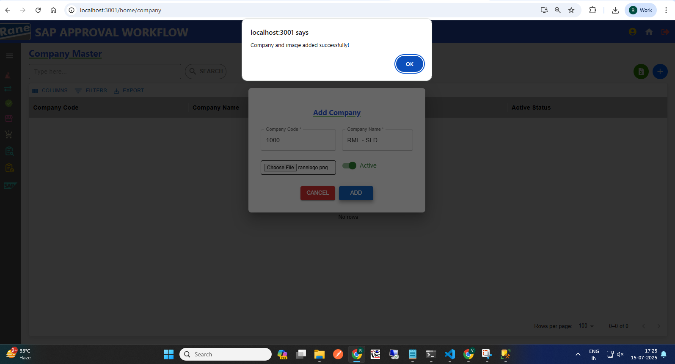

2. Update **Company Name** and **Active Status**  PASS

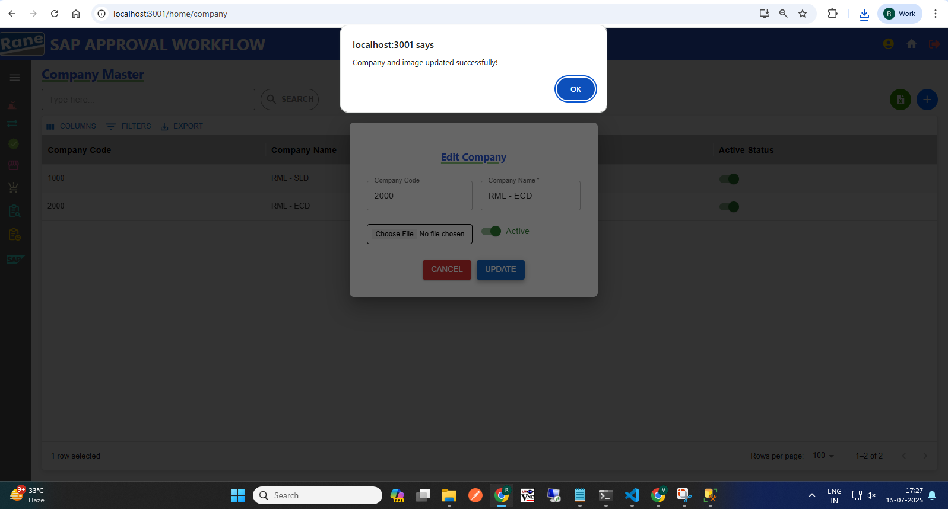

### Company Code - Disabled **(Read-Only)** PASS

### Company Name - **Editable** PASS

Company Logo - **Editable** PASS

If the user needs to change the Company Logo , they must choose a file and update it.

Otherwise, for any other updates, changing the Company Logo is not required.

Update Active Status - **Editable** PASS

### **Business Decision** **Creation / Updation Pass**

Test case - 2 :

1.**Business Division Code** Unique and (Not Allowing Duplicate) PASS

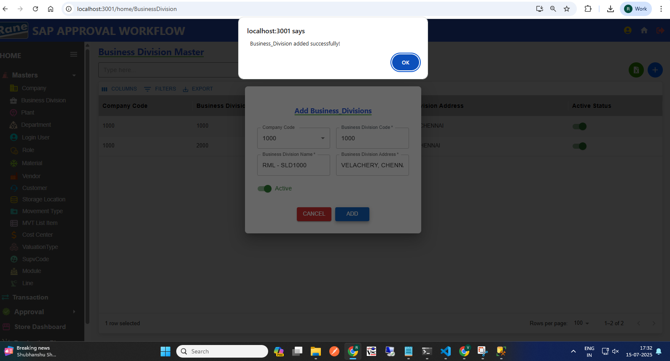

2.**Business Division Code -** Each Business Division Code must be unique within its associated Company Code. If a code already exists under the same Company Code, duplicate INSERTION IS NOT ALLOWED. PASS

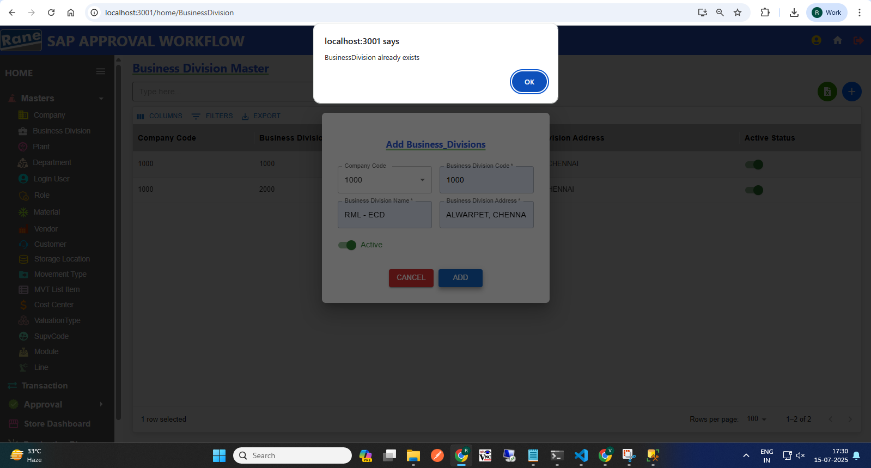

2. Update **Business Division Address** and **Active Status**  PASS

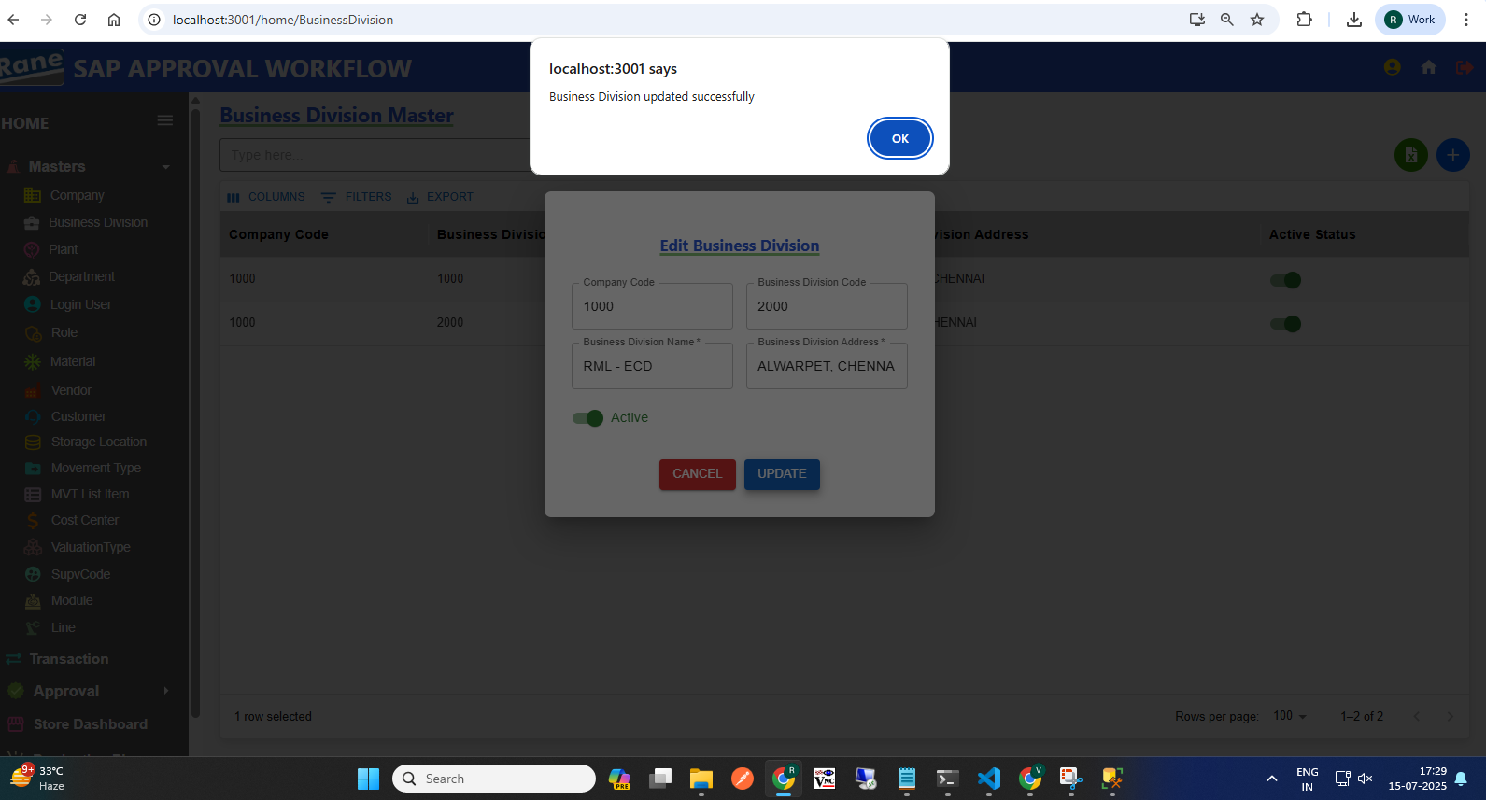

Company code - Disabled **(Read-Only)** PASS

Business Division Code - Disabled **(Read-Only)** PASS

Update Business Division Address - **Editable** PASS

Update Active Status - **Editable** PASS

**Plant Creation / Updation Pass**

Test case - 3 :

1. **Plant Code** Unique(Not Allowing Duplicate) PASS

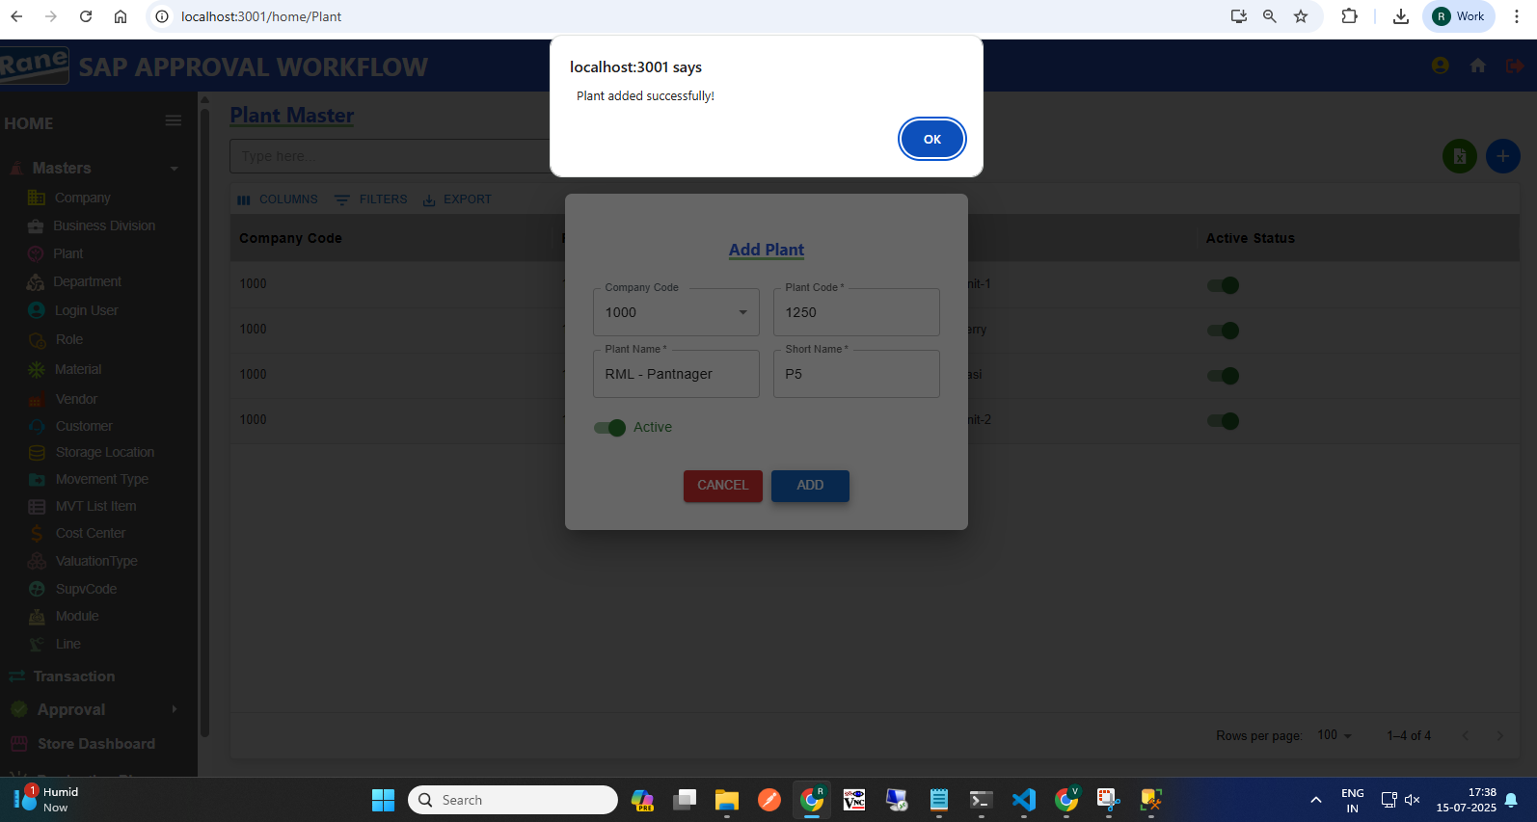

1. **Plant Code** If the same Plant Code already exists for the selected Company, INSERTION IS NOT ALLOWED. PASS

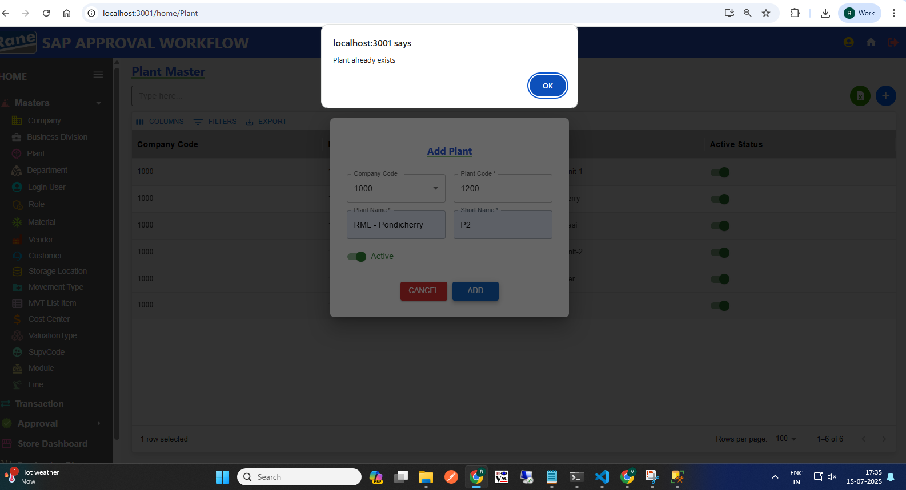

1. Update **Plant Name** and **Short_Name** PASS

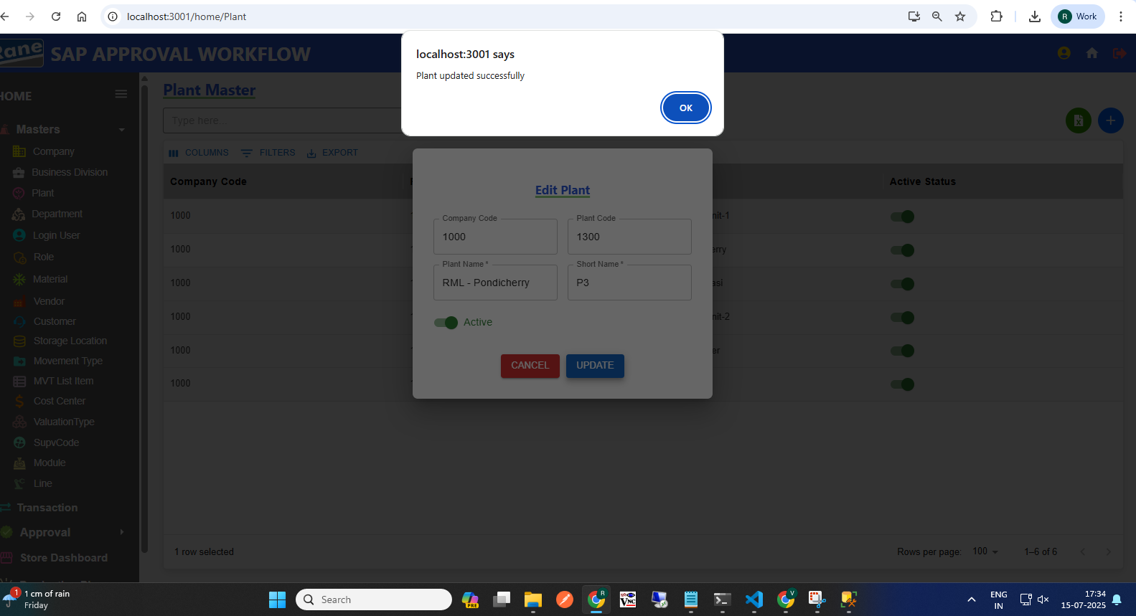

Company code - Disabled **(Read-Only)** PASS

Plant Code - Disabled **(Read-Only)** PASS

Update Plant Name - **Editable** PASS

Update Short Name - **Editable** PASS

Update Active Status - **Editable** PASS

**Department Creation / Updation Pass**

Test case - 4 :

1. **Plant Code** Unique(Not Allowing Duplicate) PASS

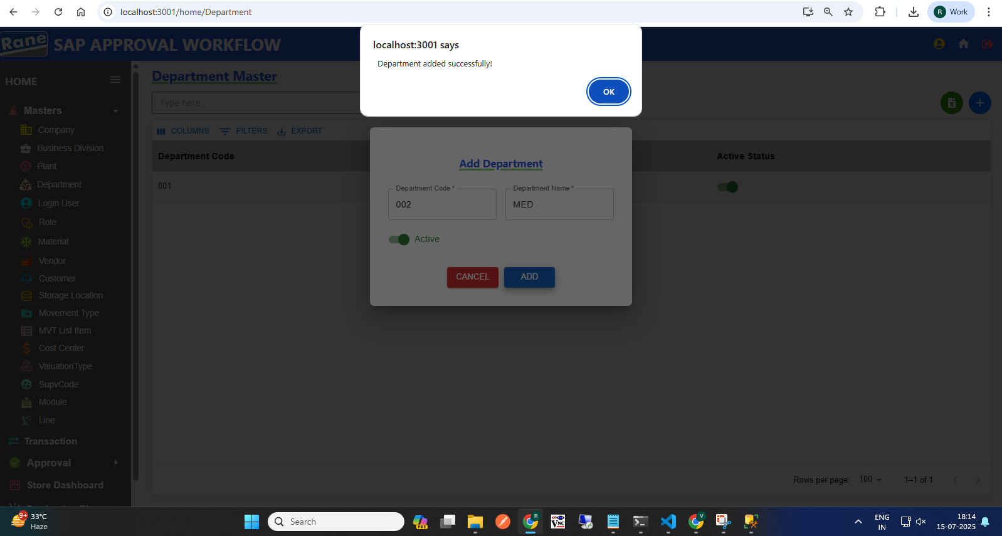

1. Department code Must Be 3 digits PASS

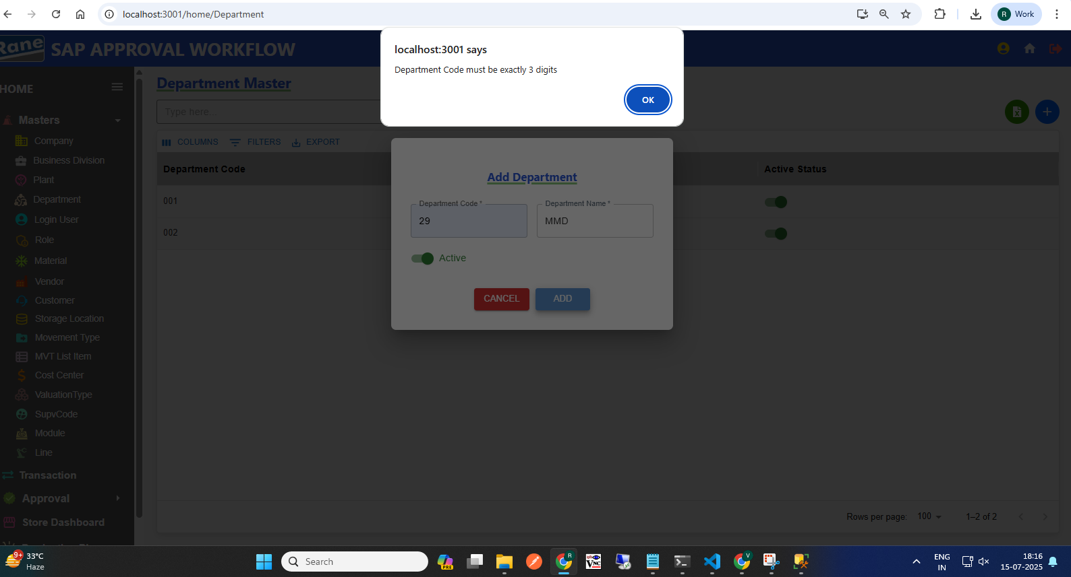

1. Edit PASS

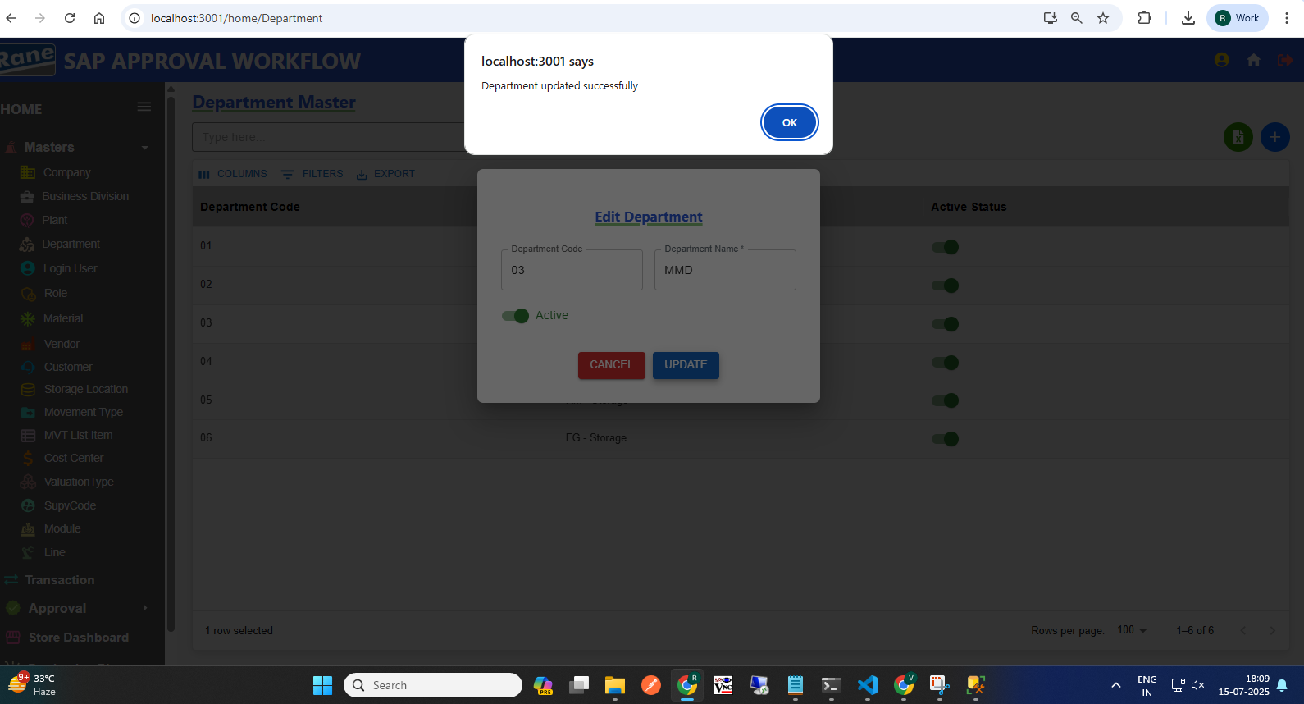

Department code - Disabled **(Read-Only)** PASS

Update Department Name - **Editable** PASS

Update Active Status - **Editable** PASS

**tmrw - User Creation / Updation**

Test case - 5 :

1. Employee ID Unique(Not Allowing Duplicate) PASS

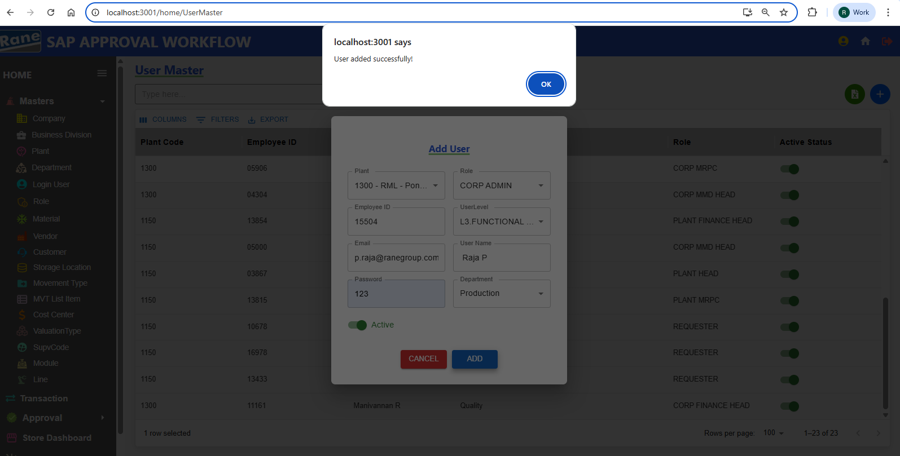

1. If The Employee ID Is Already Present In The User Master For The Selected Plant, New User INSERTION WILL NOT BE ALLOWED. PASS

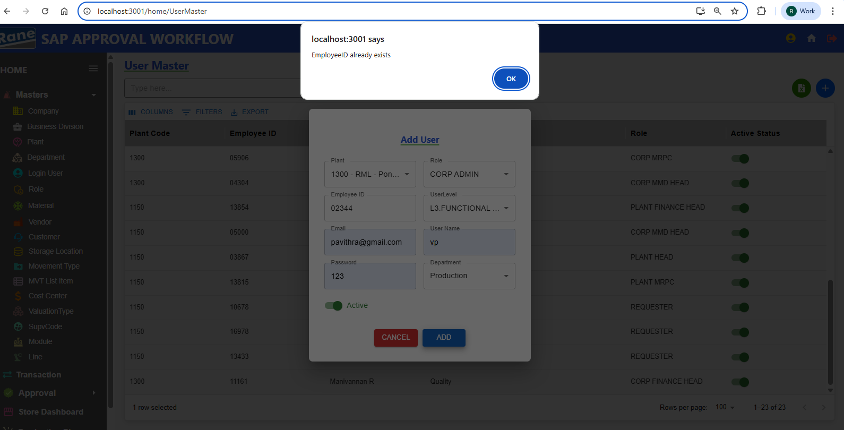

1. Update User Details PASS

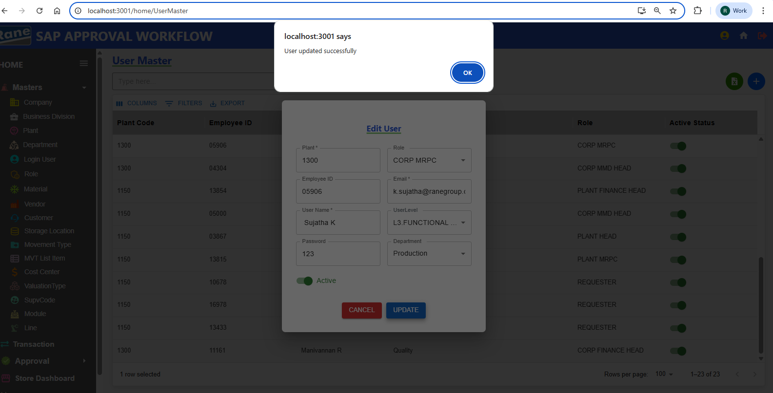

Plant code - Disabled **(Read-Only)** PASS

Employee - Disabled **(Read-Only)** PASS

Updation Role - **Editable** PASS

Updation Email - **Editable** PASS

Updation User Name - **Editable** PASS

Updation User Level - **Editable** PASS

Updation Password - **Editable** PASS

Updation Department - **Editable** PASS

Updation Active Status - **Editable** PASS

**Role**

### **Creation / Updation**

Test case - 6 :

1. Role – If the Role Name already exists in the Role Master, INSERTION IS NOT ALLOWED as it is a duplicate. Active status can be either true or false .PASS

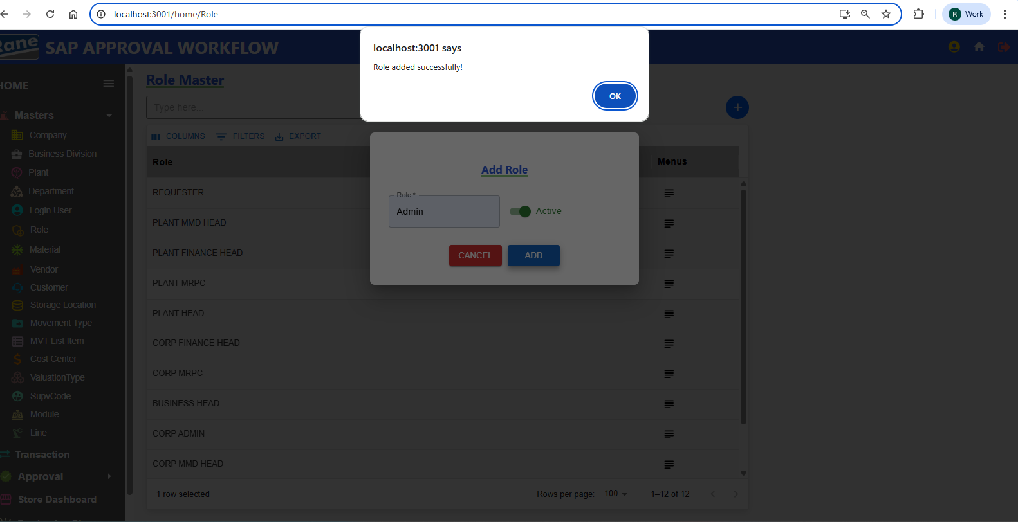

1. Updation Role Name and Active Status PASS

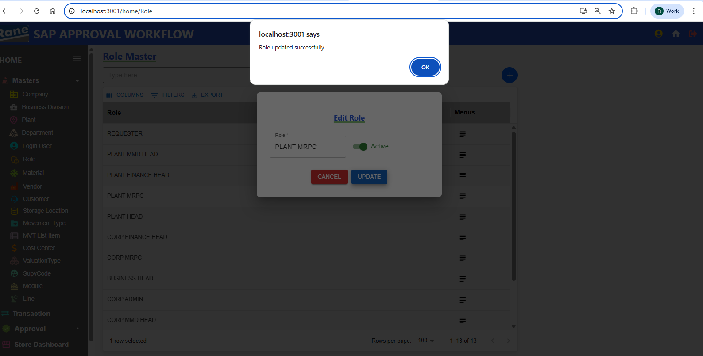

Updation Role - **Editable** PASS

Updation Active Status - **Editable** PASS

**Material**

### **Creation / Updation**

Test case - 7 : (Pending - Data)

**Vendor**

### **Creation / Updation**

Test case - 8 : (Pending - Data)

**Customer**

### **Creation / Updation**

Test case - 9 : (Pending - Data)

**Storage Location**

### **Creation / Updation**

Test case - 10 :

1. **Storage Code** Unique(Not Allowing Duplicate) PASS

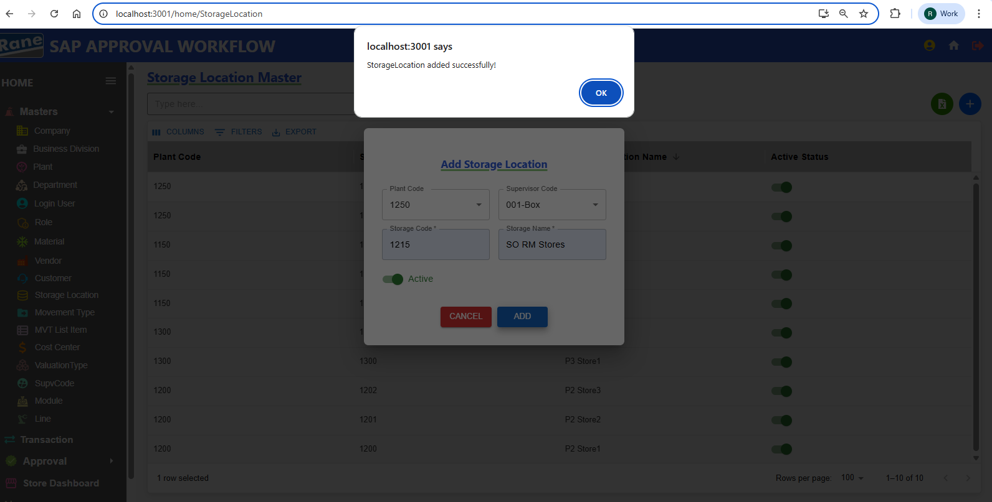

1. Storage Code Is Unique Based On The Plant. If The Storage Code Already Exists In The Selected Plant, INSERTION IS NOT ALLOWED As It Is A Duplicate.

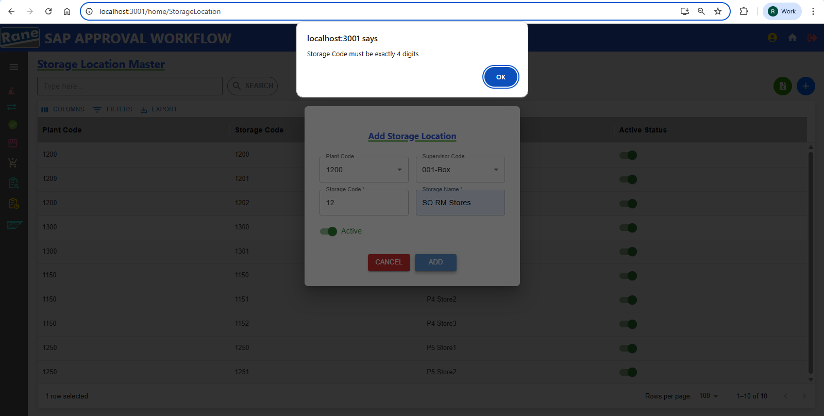

**Storage Code**  Must Be 4 Digits PASS

1. Update Storage Location PASS

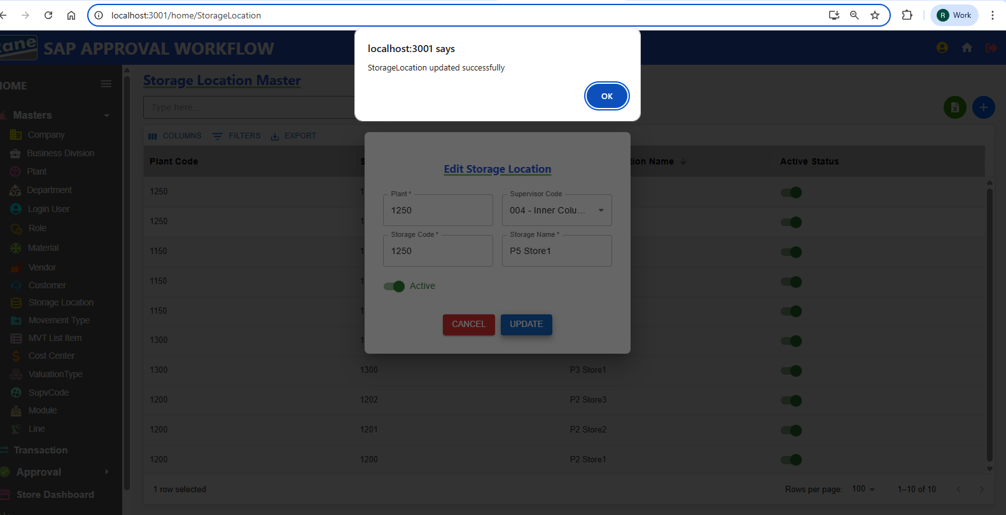

Storage code - Disabled **(Read-Only)** PASS

Plant Code - Disabled **(Read-Only)** PASS

Updation Storage Location Name - **Editable** PASS

Updation Supervisor Code - **Editable** PASS

Updation Active Status - **Editable** PASS

**Movement Type**

### **Creation / Updation**

Test case - 11 :

1. Movement Code Unique(Not Allowing Duplicate) PASS

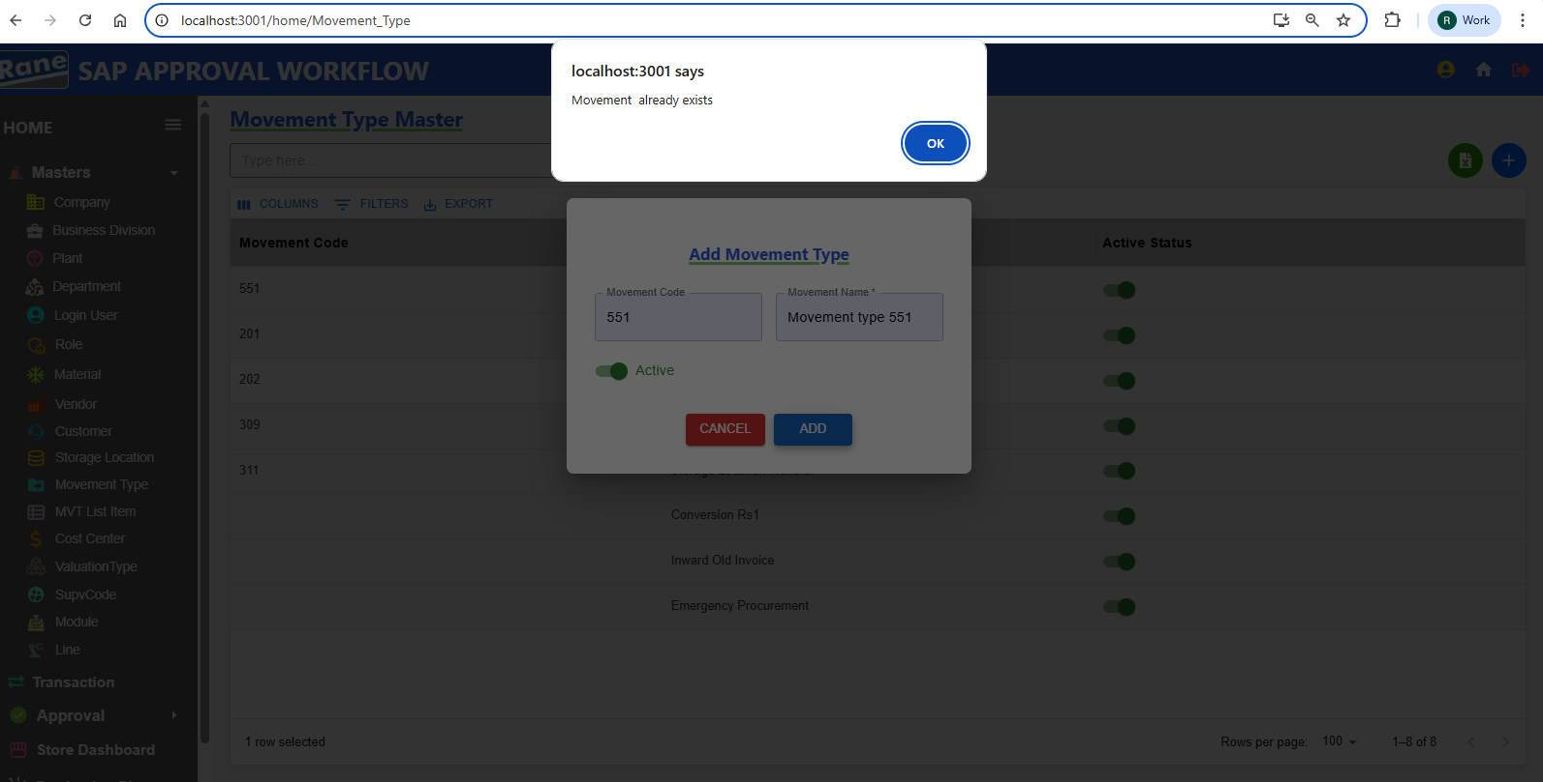

1. Update Movement Type PASS

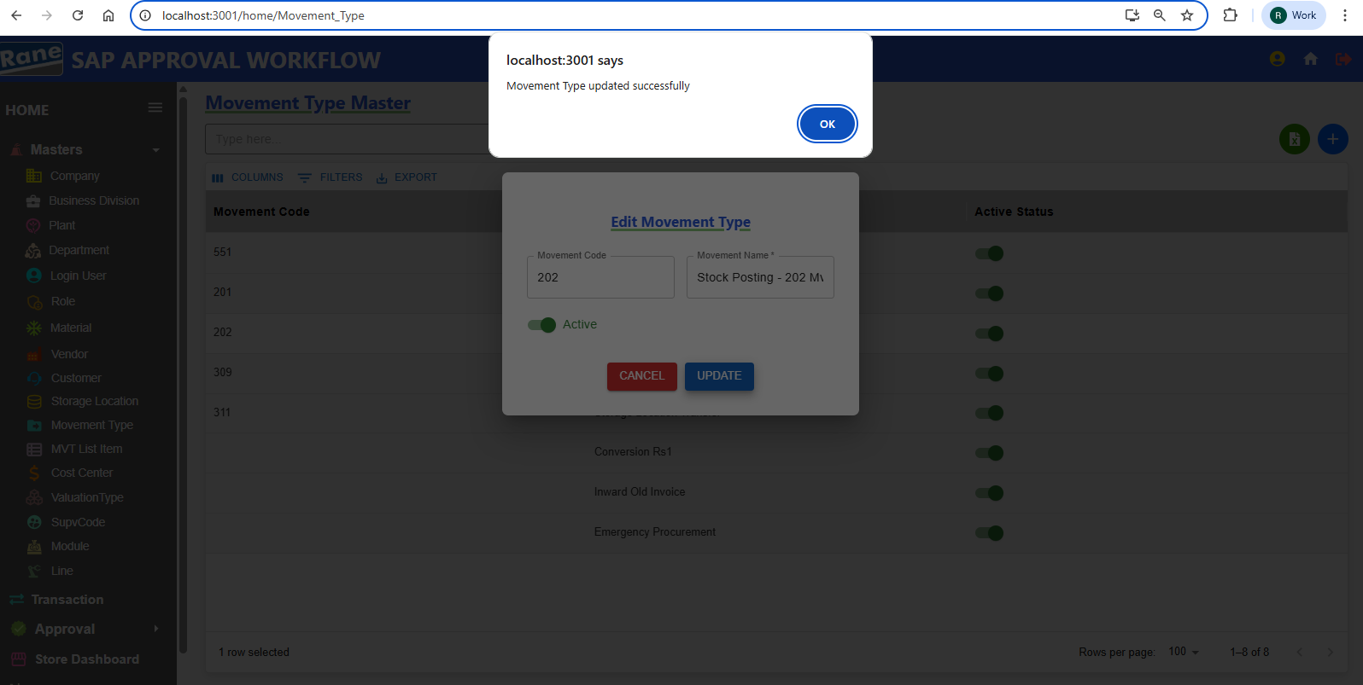

Movement Code - Disabled **(Read-Only)** PASS

Update Movement Name - **Editable** PASS

Updation Active Status - **Editable** PASS

**Movement List item**

### **Creation / Updation**

Test case - 12 :

**Cost Center**

### **Creation / Updation**

Test case - 12 : (Pending - Data)

**Valuation Type**

### **Creation / Updation**

Test case - 13 :

1. ValuationType Name Unique(Not Allowing Duplicate) PASS

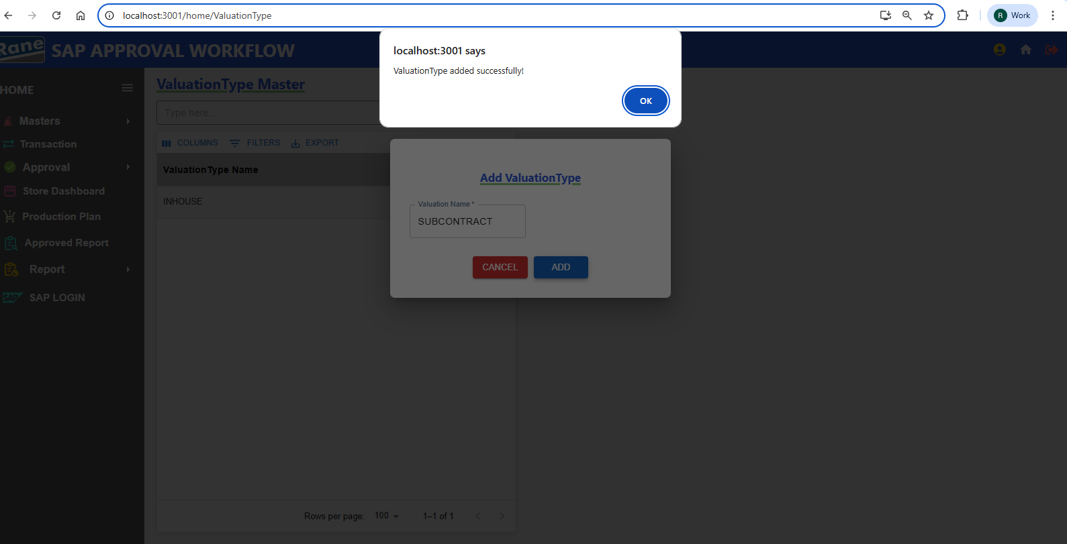

1. ValuationType Name Already Exists In The Valuation Master, INSERTION IS NOT ALLOWED As It Is A Duplicate. PASS

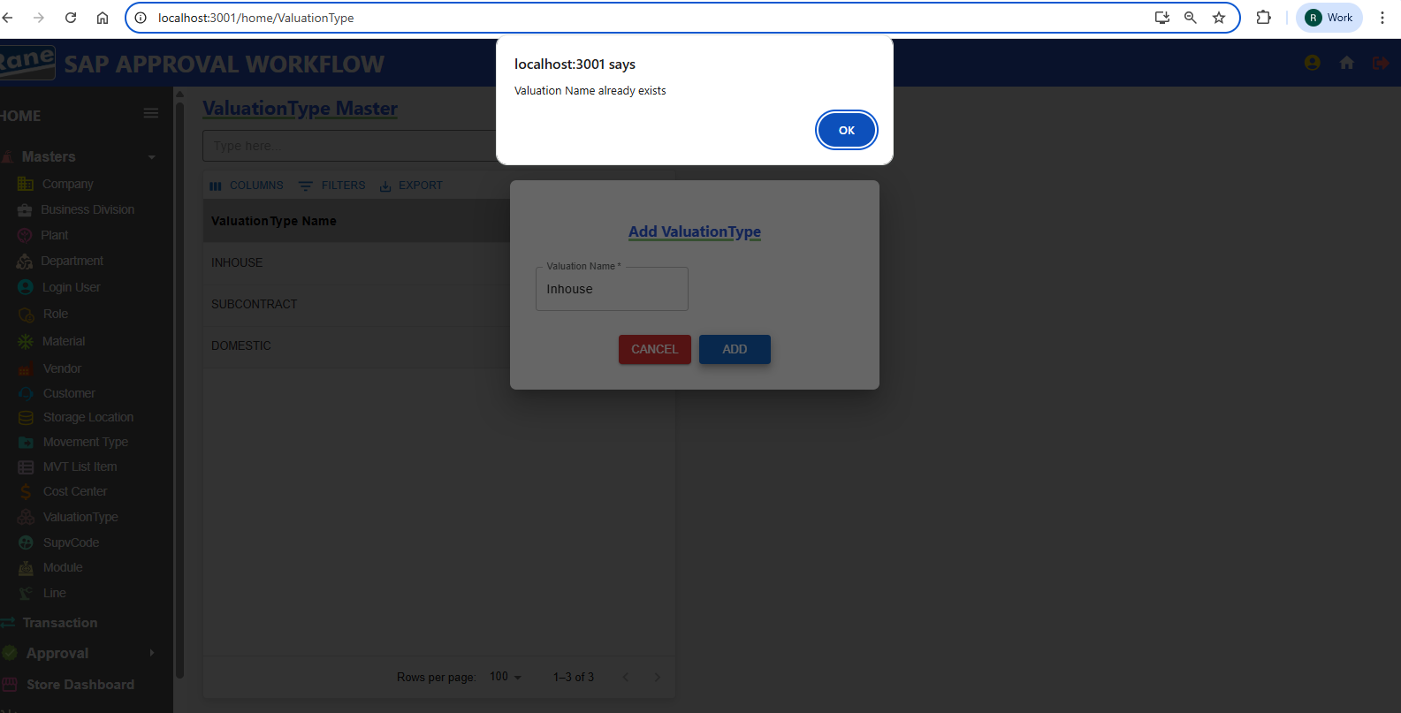

**Supervisor Code**

### **Creation / Updation**

Test case - 14 : (Pending - Data)

**Module**

### **Creation / Updation**

Test case - 15 :

1. Insert Name Based on ??????? Unique

2. Update **Module** PASS 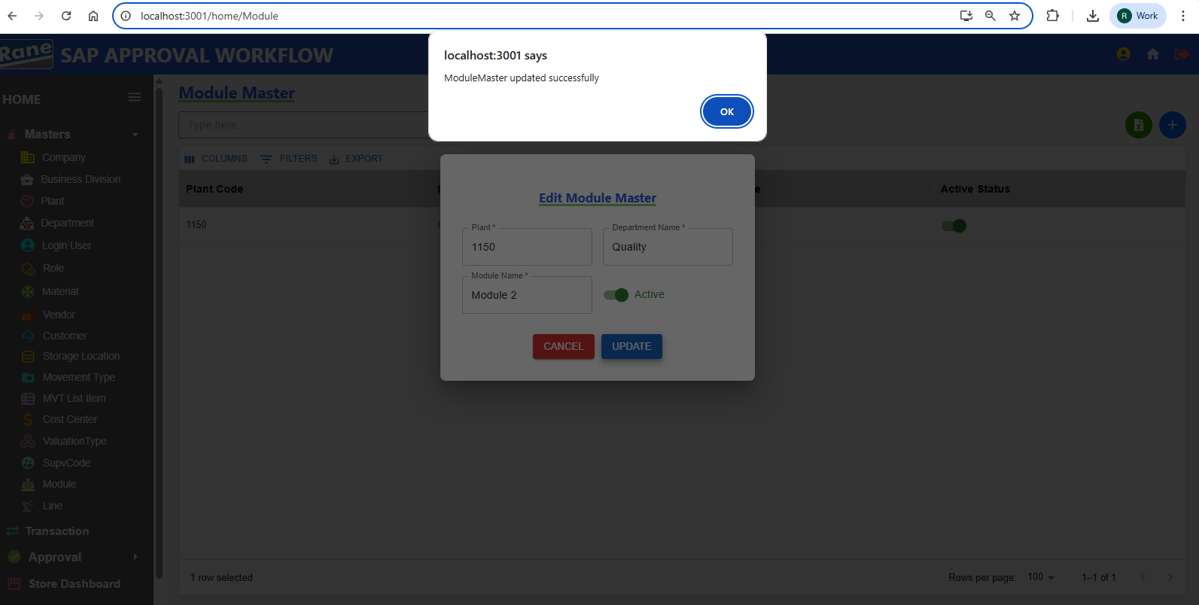

PlantCode - Disabled **(Read-Only)** PASS

Department Name - Disabled **(Read-Only)** PASS

Updation Module Name - **Editable** PASS

Updation Active Status - **Editable** PASS

**Line**

### **Creation / Updation**

Test case - 16 : (Pending - Data)

1. Create Insert Name Based on ??????? Unique
2. Update Line

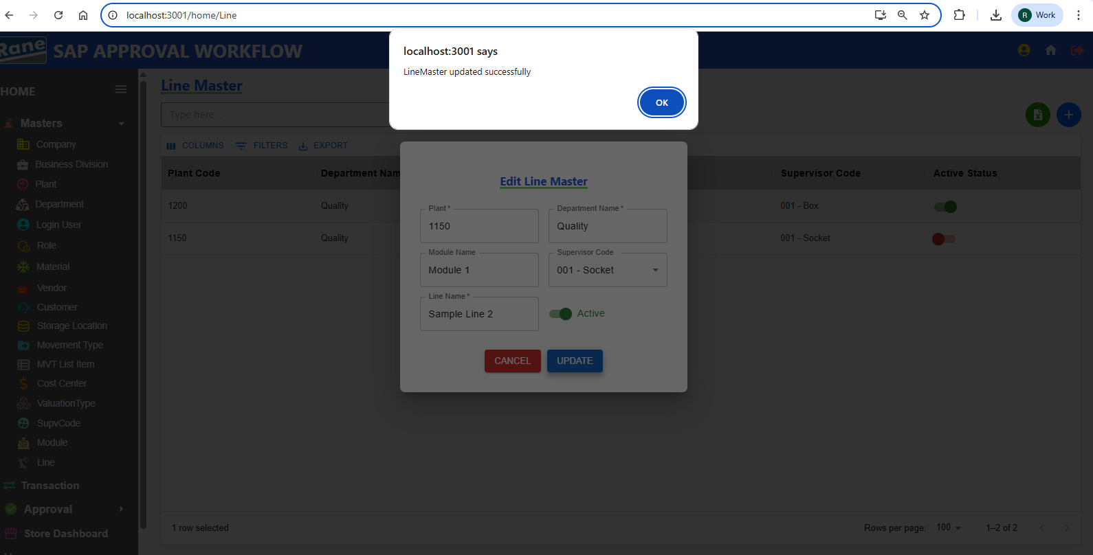

Plant Code- Disabled **(Read-Only)** PASS

Module Name - Disabled **(Read-Only)** PASS

Department Name - Disabled **(Read-Only)** PASS

Updation Supervisor Code- **Editable** PASS

Updation Line Name - **Editable** PASS

Updation Active Status - **Editable** PASS

**2.Transitions**

**309 Movement Transitions**

### **Creation / Updation**

**Test case - 1 :**

**201 Movement Transitions**

### **Creation / Updation**

**Test case - 2 :**

**202 Movement Transitions**

### **Creation / Updation**

**Test case - 3 :**

**551 Movement Transitions**

### **Creation / Updation**

**Test case - 4 :**

**311 Movement Transitions**

### **Creation / Updation**

**Test case - 5 :**

**Conversion Rs.1 Transitions**

### **Creation / Updation**

**Test case - 6 :**

**Inward Od Old Invoices**

### **Creation / Updation**

**Test case - 7 :**

**Emergency Procurement**

### **Creation / Updation**

**Test case - 8 :**

**____________________________________________________________**

### **Approval**

* 309 Approval
* 201 Approval
* 202 Approval
* 551 Approval
* 311 Approval
* Conversion Rs.1 Approval
* Inward Of Old Invoices Approval
* Emergency Procurement Approval